# CS 255 System Design Document Template

## UML Diagrams

### UML Use Case Diagram

### UML Activity Diagrams

### UML Sequence Diagram

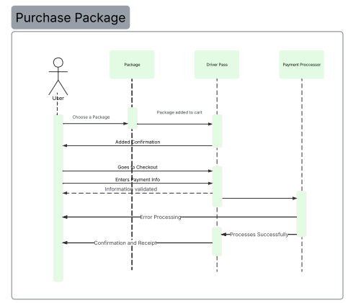

### UML Class Diagram

## Technical Requirements

Hardware Requirements

* Dedicated Server
* Reliable Internet connection
* Sufficient storage for database and website data
* Computer or mobile device for user access to the website
* Firewall to safeguard transactions

Software Requirements

* Use of a Server(Windows Server Recommended)
* SQL server for database management
* Integration of backup software
* Implementation of web server(Apache)
* Security Software

Geographic Considerations

* HighSpeed Internet Access
* Securing the database server in a data center
* Central location of server for optimal performance